Project WET

H2O Olympics

**Grade Level:** 3-6

**Classroom Time:** 30 minutes

**Materials:**

H2O Olympics Set-up Instructions

H2O Olympics Event 1 Balance Beam: A Penny card [adhesion and cohesion]

H2O Olympics Event 2 Backstroke: Clipping card [surface tension]

H2O Olympics Event 3 Sprint and Long Jump & Amazing Water Race card [adhesion and cohesion]

Twine, Towels, Pennies, Paper clips, Toothpicks, Eyedroppers, Clear plastic cups

**Objectives:**

1. Students will understand that water exists in three states, each affected by heat.
2. Students will become familiar with the adhesion, cohesion and surface tension properties of water.

**Teacher’s introduction to the material:**

Students see water’s properties of adhesion, cohesion and surface tension every day. Adhesion example: when you get out of the bath or shower, water droplets adhere to your skin. When you dry with a towel the water droplets adhere to the towel. Water likes to stick to surfaces. Cohesion example water likes to stick to water. When rain drops land on glass, do they run straight down or do they zig zag; one droplet sticking to another droplet? Surface tension example: If a glass is filled with water and then a little more water is added, the level of water will exceed the top of the glass, forming a dome called a meniscus. The meniscus is the curve in the upper surface of a liquid close to the surface of the container. It looks like a bulge and is caused by surface tension. Directions for each station are on the cards, but it is helpful to have an assistant at each station.

**Instruction:**

1. Read *Properties of Water.*
2. Review the terms cohesion, adhesion, and surface tension.
3. Give each student a score card.
4. Divide the class into 3 teams. Name the teams after bodies of water.
5. One team completes an Olympic activity at one of the H2O stations. After a period of 5 minutes tell students to switch stations.
6. At the close of visiting each station, ask students to record their total on the Score Card.
7. Demonstrate capillary action Water Walks a Tightrope or a strip of paper towel wicking up colored water.

**Skills:** Inquiry, Physical Science, Reading comprehension

**Vocabulary:** Adhesion, Capillary action, Cohesion, Evaporate, Heat of vaporization, Molecule, Surface tension

H2O Olympics. (2011). *Project WET: Curriculum and Activity Guide 2.0.* Project WET Foundation, Bozeman, MT.

Surface Tension and Water. *USGS*. Retrieved from: <http://ga.water.usgs.gov/edu/surface-tension.html>

Properties of Water

Water is composed of molecules, each with two hydrogen atoms and one oxygen atom. An easy way to remember this fact is to picture Mickey Mouse:

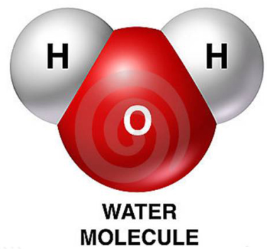

Molecules are in constant motion, rapidly increasing in motion as the temperature rises. The motion of molecules determines the state of the water: solid ice, liquid water, or water vapor. Molecules in ice are close to one another and move slowly; in water vapor the molecules move rapidly and are spaced further apart. The amount of energy needed for molecules near the surface of liquid water to ***evaporate*** is called the ***heat of vaporization***.

Water molecules tend to attract one another in a property called cohesion. In fact, it is so cohesive that when a glass if filled, then overfilled, a dome is formed above the top of the glass. This property of water is called surface tension. The cohesive forces between molecules in a liquid are shared with all neighboring molecules. Those on the surface have no neighboring molecules above and, thus, exhibit stronger attractive forces upon their nearest neighbors on and below the surface. The stronger bonds of the molecules to one another at the surface of the water causes an inward force on the surface to contract and resist being broken – surface tension.

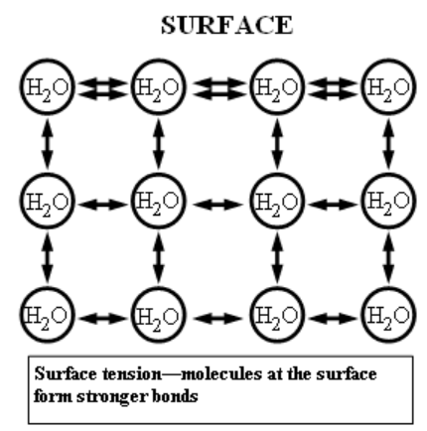

The property of water which causes it to stick to other surfaces is called adhesion. Water clings to the outside of a glass, for example, and to our skin. Water moving up a paper towel (wicking), is called ***capillary action***. Capillary action occurs when the adhesion to the surface is stronger than the cohesive forces between the liquid molecules.

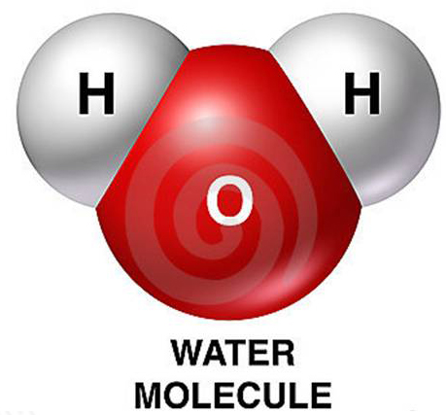

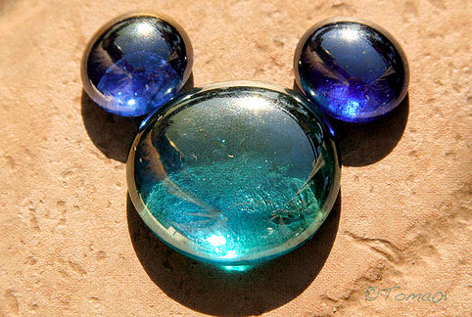

Photo by Tamás Somoskeöy

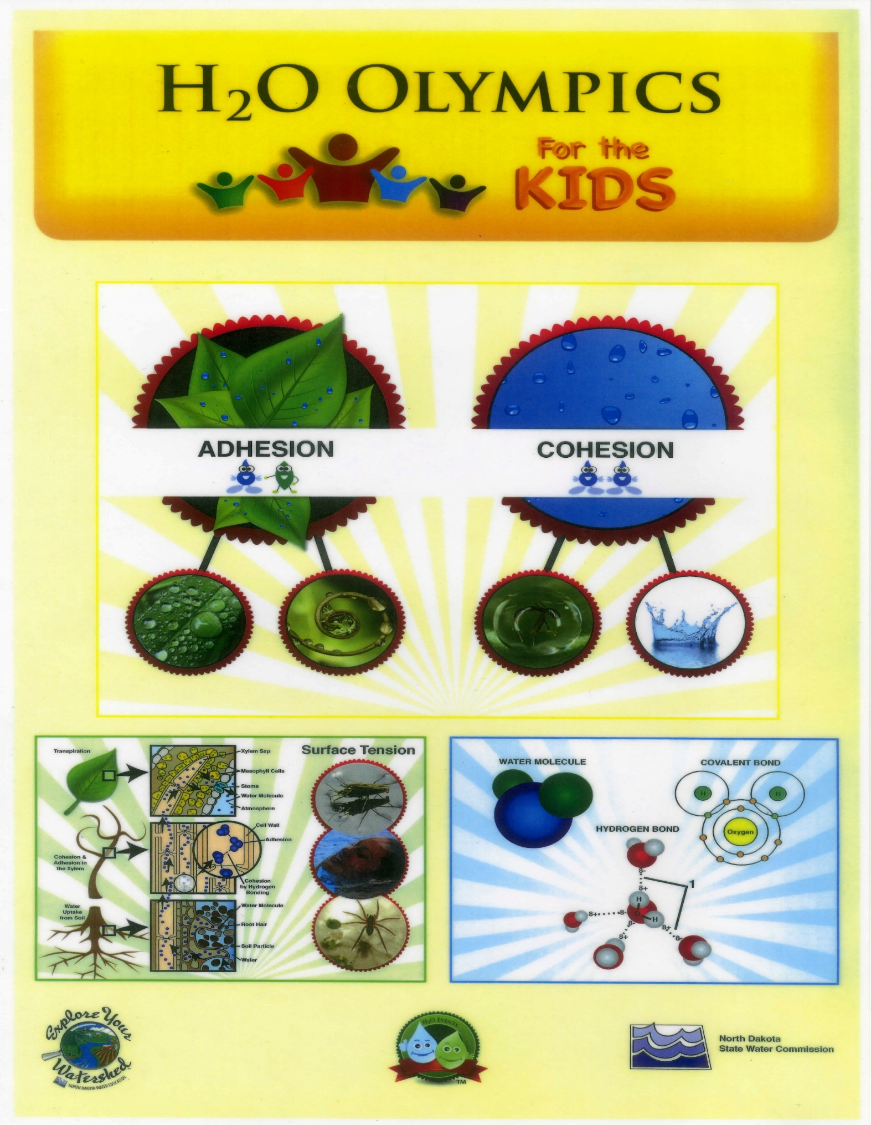

H2O Olympics Set-up

Posters: USGS water cycle [http://water.usgs.gov/edu/watercycle-kids.html], Properties of Water & water molecule photo

Pencils on the tables to record scores.

Event 1 – Balancing Beam:

Plastic plate with a penny on the plate – 4-6 on each side of the table. Plastic cups (full of water) in the center of the table with eye droppers.

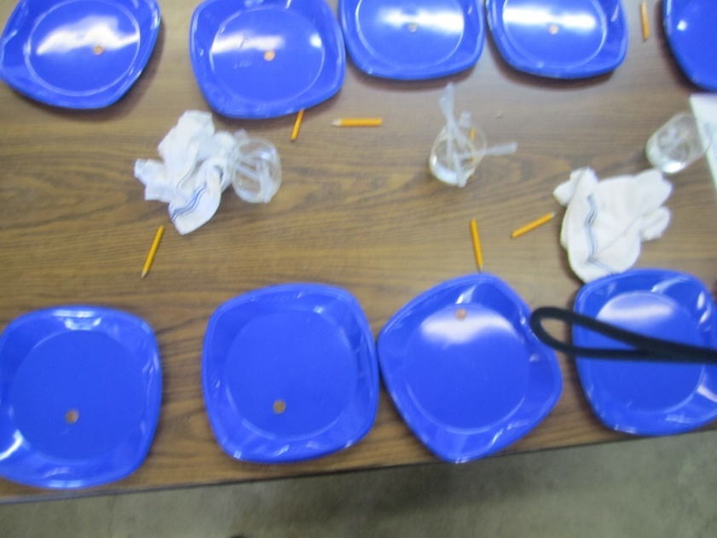

Event 2 – Backstroke:

Plastic cup (full of water) on a plastic plate – 4-6 on each side of the table. Paper clips spread out on plastic plates.

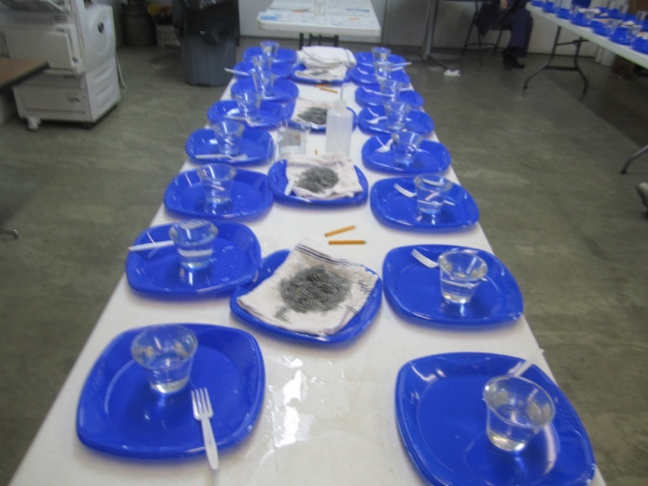

Event 3 – Sprint and Long Jump & Amazing Water Race

Maze cards 4-6 on each side of the table. A toothpick with each card. Plastic cups (full of water) in the center of the table with eye droppers.

